

**A**

**PROJECT DESIGN REPORT**

**ON**

**“ChatBot To Bargain Price For WooCommerce Portal”**

For the subject **Lab 1 Project Phase 1**

Submitted in partial fulfillment of the requirement for the award of

**Bachelor of Engineering**

**In**

**Computer Science and Engineering**

**Solapur University, Solapur**

By

|  |  |  |
| --- | --- | --- |
| Name | Roll. No. | Exam Seat No. |
| Chayan Bobra | 09 | 807028 |
| Kartik Jain | 10 | 807129 |
| Kunal Burgul | 11 | 807046 |
| Sujay Khandare | 12 | 807110 |
| Amol Dhole | 71 | 224013 |

Under Guidance Of

**Mr. P.S.R. PATNAIK**



**DEPARTMENT OF COMPUTER SCIENCE AND ENGINEERING**

**WALCHAND INSTITUTE OF TECHNOLOGY**

**SOLAPUR - 413006**

**(2018-2019)**



**CERTIFICATE**

This is to certify that the Project entitled

**“ChatBot To Bargain Price For WooCommerce Portal”**

is

Submitted by

|  |  |  |
| --- | --- | --- |
| Name | Roll. No. | Exam Seat No. |
| Chayan Bobra | 09 | 807028 |
| Kartik Jain | 10 | 807129 |
| Kunal Burgul | 11 | 807046 |
| Sujay Khandare | 12 | 807110 |
| Amol Dhole | 71 | 224013 |

as a part of Project Design Report.

Studying in BE CSE for the subject **Lab 1 Project Phase 1**

**(Mr. Guide name) (Dr.R.V.Argiddi)**

***Project Guide Head***

**Dept of Computer Science & Engg**

**(Dr. S .A. Halkude)**

**Principal**

**DEPARTMENT OF COMPUTER SCIENCE AND ENGINEERING**

**WALCHAND INSTITUTE OF TECHNOLOGY**

**SOLAPUR**

**(2018-2019)**

**INDEX**

|  |  |  |
| --- | --- | --- |
| **Sr. No.** | **Topic** | **Page No.** |
| 1 | Abstract | 4 |
| 2 | Introduction | 5 |
| 3 | Background | 6 |
| 4 | Technologies Required | 8 |
| 5 | Objective | 10 |
| 6 | Proposed Work | 11 |
| 7 | Work Planned for Next Semester | 13 |
| 8 | Conclusion | 14 |
| 9 | References | 15 |

**`**

**Abstract**

E-commerce is one of the extremely fast-paced marketing business around the world. Over the last few decades, several major e-commerce organizations have emerged such as Amazon, Flipkart that sell the majority varieties of merchandise and also other competitors like Dollar shave club and big basket are playing a major role in this highly competitive business with domesticated products.

Advantage of the use of this e-commerce manner of marketing may be available in any respect time consistent with the benefit of the customer which can also be the motive of gaining some profit within the marketplace. However, for almost, all merchandise/products charges vary. E-Commerce is a method to make the buying experience for clients extra smooth and interactive with the aid of introducing bargaining features, which are otherwise handiest familiar in physical brick and mortar stores. ChatBot additionally also utilizes machine learning in order to sell prices for sellers to look at and make a more knowledgeable and proficient selling decision.

In This Project, The Customer-Retailer interaction is our goal to imitate online in a reasonable and can be scaled. This can also be designed in a way that could provide gains for retailers to attract the majority of the attention and also all offers made by retailers need to have a specific goal to be reached to sell. Through this Bargain Model, Customers get benefited with the aid of buying the product at its quality possible price.

**Introduction**

The challenge of negotiation arises, in part, from the fact that each side has private information about their own utility function, but is ignorant of the other's values and strategies. Exacerbating this situation is the incentive that negotiators have to misrepresent their preferences[1]. Here negotiation is a communication process among parties having conflicting interests to reach an agreement. Online auction is a type of one-to-many negotiation and it is the main trading mechanism in the electronic market which proves that re-negotiation is going to play a major role in e-commerce.

There is a lot of scope of bargaining in the E-Commerce sites, but it is not possible for the e-commerce companies to hire so many persons as it will be impractical and impossible to have one person per shopper. Also, it will be very costly to have so much staff strength because their expenditure to maintain large staff will be more than their profit. Therefore

surely some machine (software) is needed which can do bargaining on behalf of the seller.

not only for all online consumers who are actively buying the product online but it also made for that consumer who is not actively engaged on e-commerce portal. This system helps those people by giving a fair amount of discount price based on their activities so it tempts

to engage more and more.

All of these businesses provide an online catalog from which customers select and buy. However, in a more traditional setting, there is one key component which most E-Commerce platforms do not provide: Customer-Retailer interaction (Bargaining of Product). And one of the reasons that some people still prefer to buy “offline” instead of online is because they can initiate in bargaining

.

**Background**

In the current existing eCommerce system, offers are initiated from the vendor's side. Vendors offer prices on products at rates at either MRP or lower in times of sale. There is no provision for customers to buy in mass, i.e customers are serviced individually rather than in bulk. So vendors sell products usually at slower single unit rates instead of bulk unit rates. Also in current eCommerce sites, there is no dynamic of the customer being able to bargain for a lower rate. This reduces the power of the customer and the flexibility of the customer.

Facebook’s FAIR[2] researchers allowed the model to achieve the goals of the negotiation. To train the model to attain its goals, the researchers had the model apply thousands of negotiations against itself, and used reinforcement learning to reward the model once it achieved an honest outcome. To prevent the algorithm from developing its own language, it was simultaneously trained to produce human-like language. To evaluate the negotiation agents, FAIR tested them online in conversations with people. Most previous work has avoided dialogs with real people or worked in less challenging domains, because of the difficulties of learning models that can respond to the variety of language that people can say.

Interestingly, in the FAIR experiments, most people did not realize they were talking to a bot rather than another person — showing that the bots had learned to hold fluent conversations in English in this domain. The performance of FAIR’s best negotiation agent, which makes use of reinforcement learning and dialog rollouts, matched that of human negotiators. It achieved better deals about as often as worse deals, demonstrating that FAIR’s bots not only can speak English but also think intelligently about what to say[2].

Background Business entities have tried for years to adapt computers and networks for use in sophisticated intercompany negotiations for commercial purchase and sales transactions, but with results that usually fall far short of expectations. Early mainframe computer attempts, for example, usually involved one corporation's allowing its existing suppliers and quantity buyers to connect to its internal private, proprietary network, using specially written locally developed application programs and private, proprietary network connections. These private systems were usually extremely costly to develop and maintain (often costing in the multi-millions of dollars) and very often did not meet all the needs and changing requirements of the participating businesses.

Since many corporations had different internal networks and computer systems, considerable effort went into working around incompatibilities. Additionally, these systems had to be based on already existing, close relationships between buyers and sellers and usually were also based on previously negotiated agreements. Thus, the systems did not help in searching for information about new buyers and sellers, nor with the evaluation or negotiation processes, nor with the documenting of those processes from the beginning. They were not interactive, but typically batch processing systems, and usually accepted alphanumeric text only, not the inclusion of graphics or sound files. They usually addressed ongoing relationships previously worked out manually, for which extremely expensive custom systems were developed at buyers' or vendors sites.

Most business (and many other) negotiation processes are usually multivariate. That is, a business negotiation deals with many variable items, such as price, quantity, quality, shippers, insurance, warranty, schedules, returns and so on. The above solutions typically did not automate multivariate negotiations in any way, since they had to be built on agreements whose terms had all been previously negotiated

**Technologies Required**

***4.1 Front End***

4.1.1) Wordpress:

WordPress[3] is a content management system (WCM) i.e. it is a tool that organizes the whole process of creating, storing and showcasing web-content in an optimal way. WordPress started its journey as an improvement tool to enhance the regular typography of day to day writing. But it was taken as a blogging tool and as we reach the last quarter of this year WordPress stands strong as the most used WCM system used and that also not only in the blogging community.

WordPress is completely an open source tool and is still being updated very frequently.

4.1.2) WooCommerce:

WooCommerce[4] is a flexible, open-source eCommerce solution built on WordPress. Whether you’re launching a business, taking an existing brick and mortar store online, or designing sites for clients you can get started quickly and build exactly the store you want.

***4.2 Back End***

4.2.1) Flask:

Flask[5] is a lightweight web application framework written in python and baseband on the WSGI toolkit and jinja2 template engine. Flask takes the flexible python language and provides a simple template for web development. Flask can be used to save time building web applications after imported into python. It has no database abstraction layer, form validation, or any other components. It keeps the core simple but extensible.

4.2.2) Python:

There is no type of declaration of variables, parameters, functions, or methods in the source code. This makes the code short and versatile, and you lose the compile-time sort. It tracks the types of all values at run time and flags code that does not make sense as it runs. It is the most trending powerful and fast, runs everywhere is friendly and easy to learn.

4.2.3) Pandas:

Pandas is a Python package offering fast, flexible, and expressive information structures designed to make operating with “relational” or “categorized” facts each clean and intuitive. Python has long been amazing for data munging and preparation, but much less so for data analysis and modeling. Pandas enable fill this hole, permitting you to carry out your complete information analysis workflow in Python without having to switch to a more domain specific language.

4.2.4) Numpy:

Numpy[6] is the most fundamental and effective package deal for running with facts python. At the core, numpy gives extraordinary nd-array items, brief n-dimensional arrays. In a 'ndarray' object ‘array’, you may keep multiple objects of the identical information kind. It is the facilities around array item that makes numpy so handy for acting math and facts manipulations.

4.2.5) Scikit-learn:

Scikit-learn[7] is this type of Python module which integrating an extensive range of contemporary machine gaining knowledge of algorithms for medium-scale supervised and unsupervised issues. This package deal makes a specialty of bringing ML to non-specialists using a high degree language. Emphasis is placed on performance, the way it is easy to use, documentation, and API consistency.

4.2.6) Pickle:

Python’s built-in Pickle[8] module implements an algorithm for serializing and deserializing objects, commonly for persistence or transport. Python Pickle module provides a known capability for running arbitrary Python functions and, by extension, permitting remote code execution; however, there is no public Pickle exploitation guide and published exploits are simple examples only.

**Objective**

The core objective is Customer-Retailer interaction to imitate online in a reasonable and scalable way. This can be done development of chatbot which is used for bargaining price of an online product based on Machine Learning algorithm which would suggests best price to a buyer based on factors such as customer loyalty, quantity, remaining stock, expiry date such that seller can maximize his profit.

**Proposed Work**

***6.1 System Architecture***

A system architecture is the conceptual model that defines the structure, behavior, and more views of a system. An architecture description is a formal description and representation of a system, organized in a way that supports reasoning about the structures and behaviors of the system.

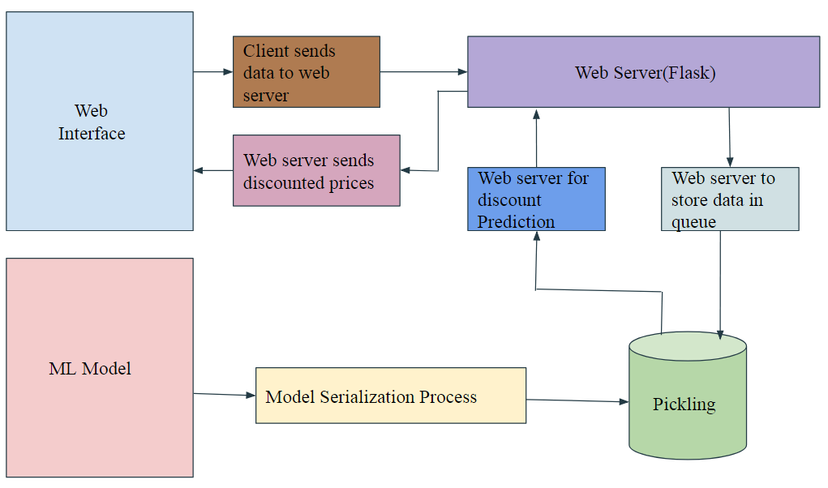

Fig 6.1 : System Architecture

***6.2 WorkFlow***

6.2.1) Build a Web Interface

This project is implemented by creating a Frontend website on Wordpress. Here Woocommerce plugins are needed in Wordpress to call API to fetch data. Based on the API for those factors which are required for bargaining; insomnia client is installed to observe how extract those API’s and get the required data from the front tend site. Further chat interface with display on client side is used for sending price the in demand of particular product to trained model.

6.2.2) Train the ML model

Here in this, we will be using either Online Retailer Dataset[9] or Brazilian E-Commerce Public Dataset[10] for training the ML model. First, we will be preprocessing the data from the dataset. The main part of the machine learning is the better data in the dataset is preprocessed it will be easy to apply the ML algorithm and get the good accuracy results. Exploring through dataset we found that this data is continuous we will try to implement Machine Learning regression algorithms and choose the algorithm with the good accuracy results fitting for this dataset. In this way the ML model is trained.

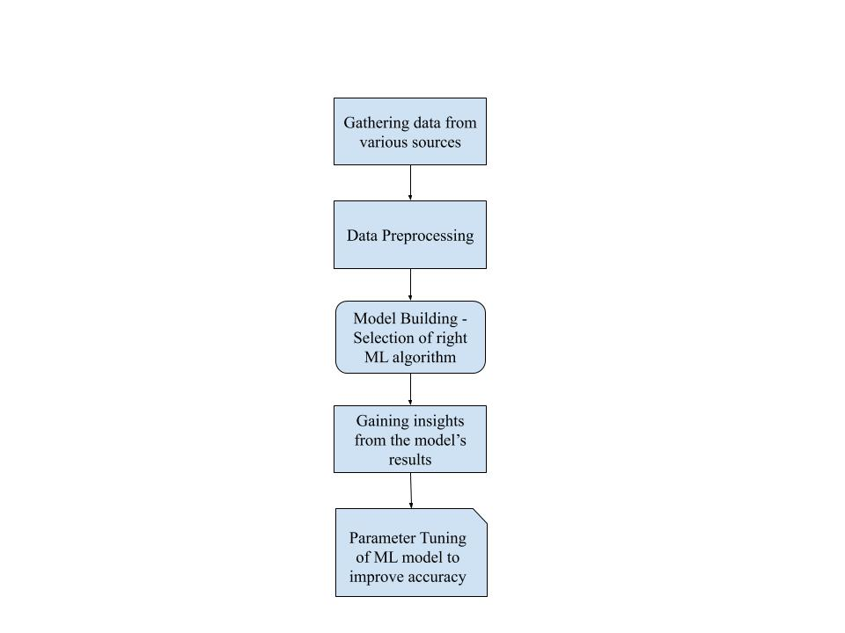

Fig 6.2: Training the ML model

6.2.3) Build the API

After training this model this is wrapped in the pickle file so that we don’t need to train the model each and every time. Once the model is good to go into an API, we can use FLASK to build them based on the requirement. Ideally, we have to build Restful APIs, since it helps in separating between the client and the server; improves visibility, reliability, and scalability; it is platform agnostic. Perform a thorough test to ensure the model responds with the correct predictions from the API[11].

6.2.3) Web Server:

Now is the time to test the web server for the API that we have built.

**Work Planned for Next Semester**

Till now we are done with the outlining of the project, we have finalized the technology requirements, how we are going to use them, we have created the frontend site using Wordpress and added the WooCommerce plugins that are required. In next phase we will be working on the core part of the project that is implementation of the ML model and connecting the Frontend to the ML model using Flask API web framework.

|  |  |  |
| --- | --- | --- |
| **Month** | **Name** | **Working** |
| December | Chayan Bobra | Exploring the datasets |
| Kartik Jain |
| Sujay Khandare |
| Amol dhole |
| Kunal Burgul |
| January | Chayan Bobra | Data preprocessing |
| Kartik Jain |
| Sujay Khandare |
| Amol dhole |
| Kunal Burgul |
| February | Chayan Bobra | Implementation of different Regression ML algorithms |
| Kartik Jain |
| Sujay Khandare |
| Amol dhole |
| Kunal Burgul |
| March | Chayan Bobra | Connecting the Frontend and backend using Flask web framework |
| Kartik Jain |
| Sujay Khandare |
| Amol dhole |
| Kunal Burgul |
| April | Chayan Bobra | Testing and Parameter Tuning of the ML model for better accuracy |
| Kartik Jain |
| Sujay Khandare |
| Amol dhole |
| Kunal Burgul |

# **Conclusion**

The Project is very useful to negotiate with the price of the product on an E-commerce site. Which will not only help the seller but it will also help the customers.

Seller Benefits :

* Identify the customers who already spend a lot with them and purchased categories like health and beauty care, electronics, and household cleaners.
* Decide (based on the discussions/exchanges) which additional products they will order to customers and at what prices they are buying it.
* The seller would benefit by increasing sales with known profitability.

Customer Benefits:

* Customers would benefit from an engaging way to capture more value from the retailer, and at the same time simplify their lives by reducing the number of retailers they have to transact With.
* The customers would get the discount in 3 phase as follows :

1 phase - In this customer will get the 50% of actual discount price.

2 phase - In this customer will get the 75% of actual discount price.

3 phase - In this customer will get full 100% of actual discount price.

In addition, e-commerce oriented negotiation is going to play a vital role in many organizations and its significance is increasing day by day.

# **References**

[1]Jim R.Oliver ,“A Machine Learner Approach to Automated Negotiation and Prospects for Electronics Commerce”

[2]Mike Lewis, Denis Yarats, Yann N. Dauphin, Devi Parikh, “Deal or No Deal? End-to-End Learning for Negotiation Dialogues”

# [3]<https://www.geeksforgeeks.org/introduction-wordpress/>

[4]<https://wordpress.org/plugins/woocommerce/>

[5]Fankar Armash Aslam ,Hawa Nabeel Mohammed Efficient ,”Way Of Web Development Using Python And Flask”.

[6]Stéfan van der Walt, Stellenbosch University South Africa,S. Chris Colbert, Enthought USA,Gael Varoquaux, INRIA Saclay France ,“The NumPy array: a structure for eﬃcient numerical computation”

[7]Fabian Pedregosa , Gael Varoquaux , Alexandre Gramfort , Vincent Michel , Bertrand Thirion “Scikit-learn: Machine Learning in Python”.

[8]Marco Slaviero,’’Sour Pickles Shellcoding in Python’s serialization format”

[9]“Online Retailer Dataset”, UCI Machine Learning Repository Center for Machine Learning and Intelligent Systems

[10]“Brazilian E-Commerce Public Dataset by Olist”, Kaggle

[11] Vaibhav Kumar, “Deploy Machine Learning Models for Free Using Flask API from Medium”